**MS SQL SERVER**

**Standard Operating Procedures**

**(SOP)**

**Disk space alert check**

Submitted to



**By**



CIS, Wipro Limited

Document Details

|  |  |
| --- | --- |
| Project Name | Innogy SE |
| Account | CIS |
| IT Component/Application Title | Disk space alert check |
| Current Version | 1.2 |
| List of Contributors | Pradipkumar Kansara, Kiran Bhalekar, Ayushi Gautam, Sivakumar Goud, Ayushi Srivastava |
| Customer Contact Information |  |

Version History

(All revisions made to this document must be listed in chronological order. All revisions must be approved. Review and Approval can be done by an internal source or by the customer)

|  |  |  |  |  |  |
| --- | --- | --- | --- | --- | --- |
| Version | Date of Revision | Description | Author | Reviewed By | Approved By |
| 1.0 | 08-12-2017 | Initial Draft | Kiran Bhalekar | Pradipkumar Kansara | Santosh Badiger |
| 1.1 | **13-12-2017** | **Document Completed** | **Kiran Bhalekar** | **Pradipkumar Kansara** | Santosh Badiger |
| 1.2 | **19-12-2018** | **Content Updated** | **Ayushi Srivastava** | **Pradipkumar Kansara** | Santosh Badiger |

Document Distribution List

|  |  |  |
| --- | --- | --- |
| **S.No** | **Name and Company** | **Purpose** |
| **1** | RWEIT-SQLDBA | **This document is useful to understand the space issues and how to resolve them** |
| **2** |  |  |

**TABLE OF CONTENT**

1. Purpose 4

2. Scope 4

3. Disk space issues and their resolution 4

4. Reference 19

# 

# Purpose

This document is to cover the day to day issue of disk space and how to resolve them.

# Scope

This document is prepared for GSMC Wipro sustenance team and provides the workaround/resolution of disk space issues

# Disk space issues and their resolution:

As per our standard installation process, we follow a standard to create data files, log files and backup file into specific drives as follows:

Data files: E drive

Log files: F drive

Tempdb data file: G drive

Backup: G drive

Normally we work on the disk space issues which happen on these drives which are mentioned above.

1. We will start with E drive space issue: As you see in the below screenshot we have received and email alert stating that server has only 4% free space available on E drive.

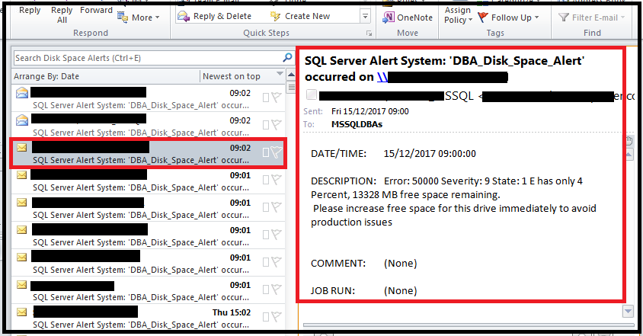

**Steps to release space/create free space:**

1. First of all, you have to RDP the server.
   1. Go to ‘RUN’ type ‘mstsc’
   2. Enter your credentials
   3. Click on ‘OK’

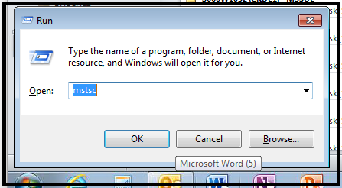

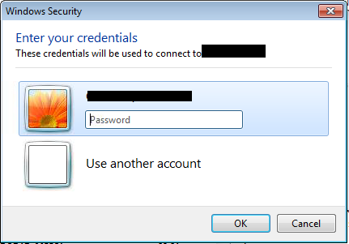

1. Now go to ‘My computer’. You will be able to see the drive space here as per the screenshot.

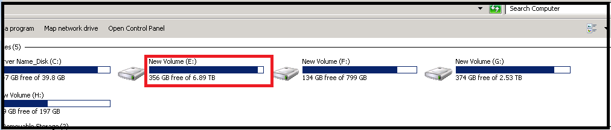

1. Here disk space is below 10% threshold. We will go to the following path and will check which database data file has occupied more space on the drive

E:\MSSQL10_50.MSSQLSERVER\MSSQL\DATA\

1. Here we are looking at server which has default instance and that is why path contains folder named as MSSQL10_50.MSSQLSERVER. This folder name will change as per the named instance.

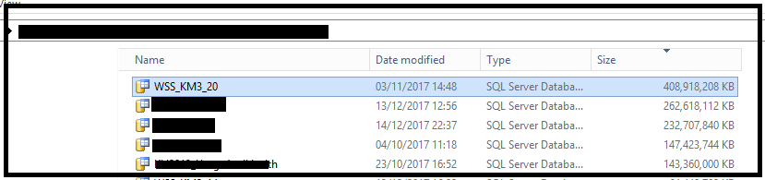

1. Now here we are seeing a file WSS_KM3_20 which has occupied more space on the drive.
2. We will login to SSMS now and will check if there is any free space available in this WSS_KM3_20 database’s data files.
3. To check the free space from the data files we will right click on database and will follow following path:

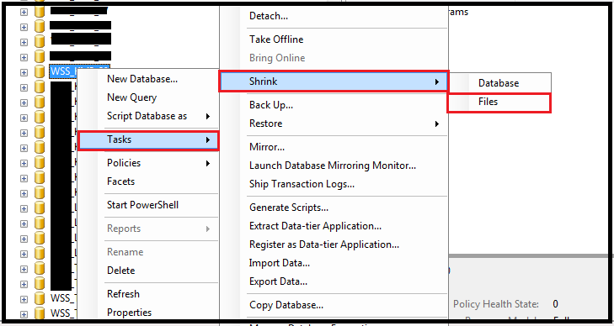

1. Once you click on files you will be able to see below window:

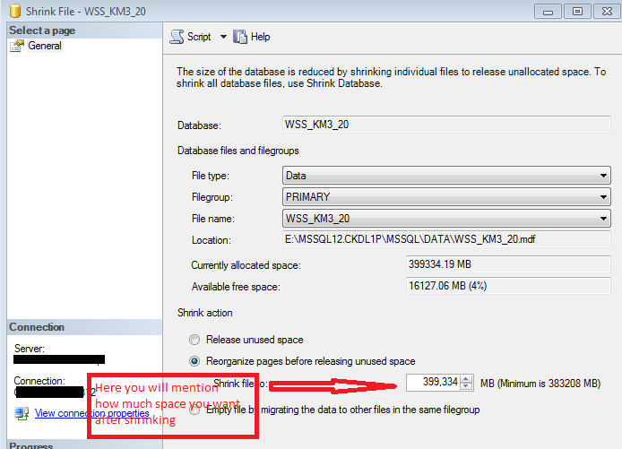

1. As per the microsoft’s recommendation, normally we don’t shrink data files but if required and if it is an urgency then only we can go for it.
2. As per the above screenshot, click on ‘Reorganize pages before releasing unused space’ and mention the total space which you want after shrinking and then click on ‘OK’ (You can script out this and execute with the help of query executor also. Just click on ‘SCRIPT’ option which is present at upper side of window and then you can execute it in normal way.)
3. Again check the space, if it is above 10% threshold then you can stop here. Otherwise go for another files and do the same procedure till your drive comes above threshold.

Note: As mentioned this is not standard practice, so before shrinking the data file please check that if you really want to do it or not. If any critical application is there then go for disk expansion

Please find below the disk expansion template, which you can use to create Change request.

CHGMOD0004107

1. Now we will start with F drive space issue: As you see in the below screenshot we have received and email alert stating that server has only 1% free space available on F drive.

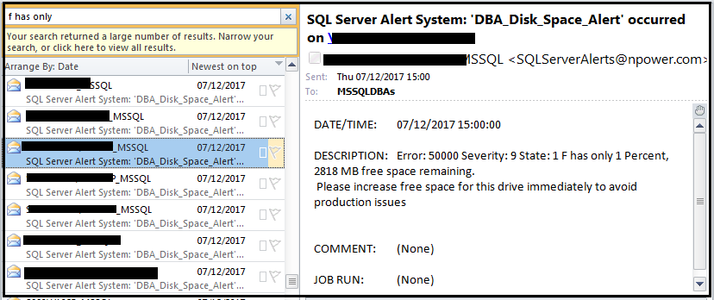

Follow the same procedure as we have followed for E drive till checking the disk space as

1. Login on the server with credentials
2. Check F drive space
3. Go to the folder where all .LDF files are present
4. We have checked the data file which has max size and then we shrank it for E drive, we will do the same here. We will first find the log file which has utilized more space on F drive and accordingly we will below steps.
5. Open SQL Server management studio
6. Connect with the server name and instance name of that server
7. Locate the database, whose log file has grown and utilized more space on F drive
8. Once you find the database right click on it, and then follow below steps:
   1. Tasks -> Shrink -> Files (Click on files)

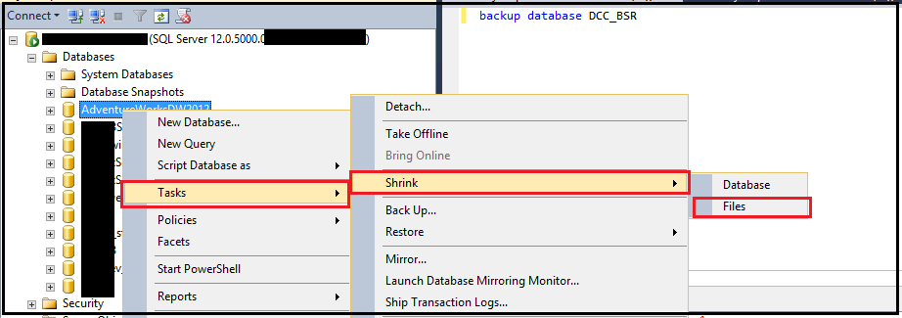

1. Once you click on files, you will see below window.

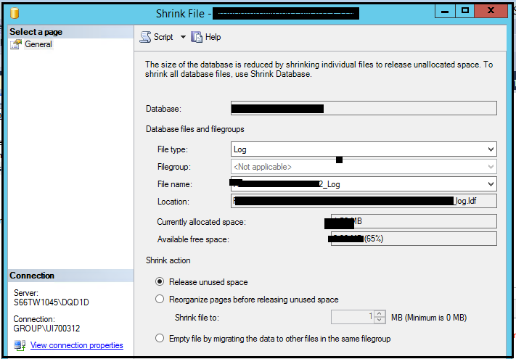

1. Script it out, as if you directly click on OK and release the space then it will discard the transaction logs which would be present in the log file.
2. Once you script it out then first take the log backup of that database and then execute this script in order. So that it will first take the log backup of all transactions and then it will release the free space which is available in that log file

Script to take backup followed by shrink statement:

Backup log <database_name> to disk = ‘path’ Go

USE [<database_name>]   
 GO   
 DBCC SHRINKFILE (N'<Log file name>', 0, TRUNCATEONLY)   
 GO

1. Now check the disk space again, If needed then follow the same steps for another log files and create some free space.
2. Now we will start with G drive space issue: As you see in the below screenshot we have received and email alert stating that server has only 5% free space available on G drive.

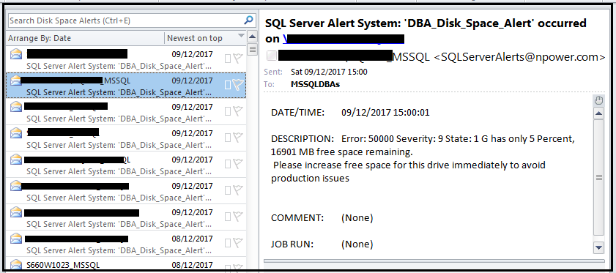

Follow the same procedure as we have followed for E drive till checking the disk space as

1. Login on the server with credentials
2. Check G drive space
3. As per our standard installation procedure, we have tempdb data files and backup files of database. So before creating free space or clearing some space, we have to check two things:
   1. Whether disk contains any old backup files
   2. How much size tempdb has utilized
4. So we will first check if any old backup file is present on G drive or not. If it is present then we will delete it and try to free some space.

Paths to check backup files: ‘G:\MSSSQL.(Default/instance name)\MSSQL\Backup\’

1. If no old backups are present then we will check the size of tempdb files.
2. Now we will open SSMS and then we will connect to the specific instance of that server.
3. Now, expand database, then expand system database.
4. Right click on tempdb and then click on new query and write following query:

USE [tempdb]

Go

dbcc freesystemcache('all')

GO

DBCC SHRINKDATABASE(N'tempdb' )

GO

1. You can use GUI as follows to do the same shrinking of tempdb database.
2. Right click on tempdb -> tasks -> shrink -> Database

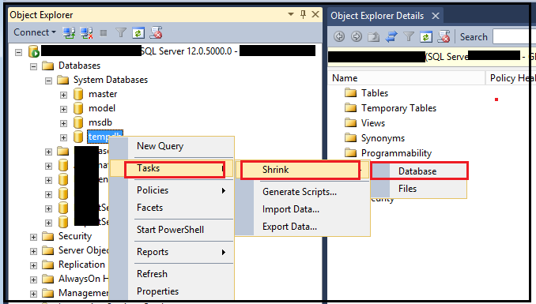

1. After clicking on database you will be able to see below window

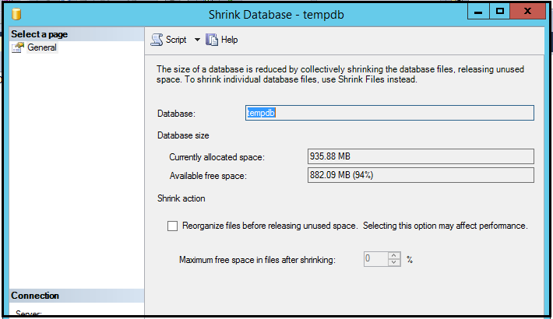

1. Now click on ok, it will shrink the database files.

# References:

<https://www.mssqltips.com/sqlservertutorial/3311/how-to-shrink-the-transaction-log/>

<https://docs.microsoft.com/en-us/sql/relational-databases/databases/shrink-a-file>